 | SIMATS ENGINEERING  Department of Computer Science and Engineering
CSA15 Cloud Computing and Big Data Analytics
CO4 AT2 - Big Data Industry Problem Solving Guided Tool Workbook
Course Code | CSA15 | Slot | B
Assessment | CO4 AT2 | Bloom Level | BL4 - Analyze
Faculty | Dr C. Rajesh Babu | Employee ID | SSETSCS415
Mode | Individual guided tool-based workbook | Submission | GitHub repository link through Google Classroom
End Evidence | Workbook + screenshots + diagrams + dashboard/mockup | Marks | 30

Student Details
Student Name | M Deepika | Register Number | 192311027
Class / Section | BE CSE | Slot | B
Selected Scenario | Healthcare Emergency Analytics | Submission Date
GitHub Link |  | Google Classroom Status

Workbook Purpose
What this workbook does
This workbook guides students to use real software tools and official technical references to derive a big-data industry solution. Students should learn from the tool, observe patterns, record evidence and then write their own technical explanation.
- Do not copy full text from websites or AI tools.
- Use official references to justify architecture, processing and security decisions.
- Screenshots are evidence; explanations are the actual assessment answer.

Scenario Bank
Instruction
Faculty may assign one scenario or ask students to complete more than one. If no specific scenario is assigned, select one scenario and complete all tool-guided sections for that scenario.
No. | Scenario | Data Context
1 | Healthcare Emergency Analytics | Emergency department data, ambulance updates, bed availability, alerts and treatment delays.
2 | E-Commerce Customer Behavior Intelligence | Clickstream events, cart abandonment, payment failure, campaign traffic and recommendation impact.
3 | Smart Agriculture Advisory Platform | Weather, soil sensors, crop advisories, pest reports, market prices and farmer app interactions.
4 | Cybersecurity Threat Monitoring | Authentication logs, firewall alerts, API access logs, failed login attempts and suspicious network events.
5 | Public Transport Demand Analytics | Ticketing data, bus GPS, passenger count, route delay, peak-hour demand and crowding alerts.

Selected Scenario and Reason
Selected Scenario: Healthcare Emergency Analytics
I selected the Healthcare Emergency Analytics scenario because it is closely related to my capstone project, “Cloud-Based Medicine Inventory Management System.” The system manages medicine stock, availability, expiry information, and inventory updates using cloud-based technologies. Big data analytics can help monitor medicine usage, identify low-stock medicines, analyze demand patterns, reduce medicine shortages, and support faster healthcare inventory decisions.

Guided Tool Module 1: Use Cloud Architecture Centers
Purpose: Use official cloud architecture references to identify suitable ingestion, storage, processing, analytics and security components for the selected scenario.
No. | Perform |  | Observe / Decide |  | Record in Workbook
1 | Open AWS Architecture Center, Azure Architecture Center and Google Cloud Architecture Center in three browser tabs. |  | You are not copying a full architecture. You are learning common cloud patterns and service categories. |  | Paste the three page titles or URLs.
2 | Search each site using terms from your scenario, such as healthcare analytics, streaming analytics, data lake, retail analytics, IoT analytics or security monitoring. |  | Notice which patterns repeatedly appear: ingestion, data lake, warehouse, processing, ML/analytics, visualization and security. |  | Record at least one useful reference from each cloud provider.
3 | Identify the services/components mentioned in the reference diagrams. |  | Separate service category from vendor-specific service name. Example: object storage is the category; Amazon S3/Azure Blob Storage/Cloud Storage are service examples. |  | Complete the tool-category table.
4 | Compare the three references. |  | Choose the most suitable architecture pattern for your scenario and explain why. |  | Write a short justification.
5 | Draw your own provider-neutral architecture in draw.io. |  | Your diagram must show data sources -> ingestion -> storage -> processing -> analytics/dashboard -> users, with security controls. |  | Paste the diagram screenshot/link.
Cloud Provider |  | Reference Page / URL |  | Useful Pattern Found |  | Useful Service Categories
AWS |  | Healthcare Analytics Reference Architecture – AWS |  | Data ingestion → Data Lake → Analytics/ML → Dashboard/Users |  | Data ingestion, Object Storage, Data Lake, Data Warehouse, Machine Learning, Visualization, Security
AZURE |  | Improve Clinical and Operational Analytics – Microsoft for Healthcare |  | Data Sources → Data Factory → Microsoft Fabric/OneLake → Analytics → Power BI |  | Data ingestion, Lakehouse Storage, Data Processing, Analytics, Visualization
Google Cloud |  | Automate Utilization-Review of Health Insurance Claims – Google Cloud Architecture |  | Data Sources → Ingestion → Cloud Storage/Firestore → Processing/AI → Users |  | Cloud Storage, Database, Processing, AI/ML, Security

Cloud Architecture Justification
For the Cloud-Based Medicine Inventory Management System, a cloud-based data analytics architecture is suitable because medicine stock, usage, expiry, and availability data must be collected, stored, processed, and analyzed efficiently. The selected architecture follows the common pattern of Data Sources → Data Ingestion → Cloud Storage/Data Lake → Processing and Analytics → Dashboard → Users. This architecture supports scalable storage, real-time inventory monitoring, low-stock and expiry alerts, analytics, and secure access to medicine inventory information.

Architecture Diagram Evidence
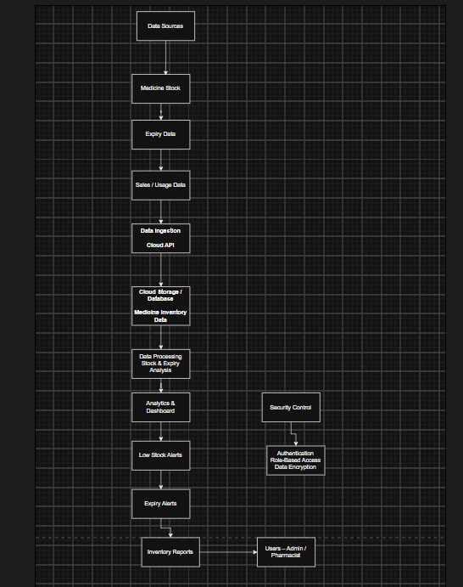
Figure: Provider-Neutral Cloud Architecture for Cloud-Based Medicine Inventory Management System
The proposed architecture collects medicine stock, expiry, and usage data through a cloud API. The data is stored in a cloud database and processed for stock and expiry analysis. The analytics dashboard generates low-stock alerts, expiry alerts, and inventory reports for administrators and pharmacists. Authentication, role-based access, and data encryption provide security for the system.

Guided Tool Module 2: Use Hadoop and Spark Documentation
Purpose: Decide whether your problem needs batch processing, streaming processing or hybrid processing by reading official Hadoop/Spark documentation.
No. | Perform |  | Observe / Decide |  | Record in Workbook
1 | Open the Apache Hadoop MapReduce tutorial. |  | MapReduce is suitable when large stored data can be processed in batches, such as daily logs or historical transactions. |  | Write one sentence on what mapper and reducer mean.
2 | Open the Apache Spark Structured Streaming guide. |  | Structured Streaming is suitable when new events continuously arrive, such as sensors, clickstream, live alerts or location updates. |  | Write one sentence on what streaming source, processing and sink mean.
3 | Classify your scenario data into batch data and streaming data. |  | Historical records normally become batch data; live sensor/log/API updates normally become streaming data. |  | Complete the batch-vs-stream table.
4 | Choose one processing approach for your scenario: Hadoop/MapReduce, Spark batch, Spark streaming or hybrid. |  | The decision must match the data velocity and decision urgency. |  | Write your processing decision.
5 | Prepare a simple pseudo-flow, not full code. |  | Example: Mapper reads log line -> emits hour, count. Reducer sums counts. Dashboard shows peak hour. |  | Write pseudo-flow or paste diagram.
Data Item |  | Batch / Streaming |  | Why |  | Suggested Framework
Medicine Stock Records |  | Batch |  | Stored medicine stock data can be processed periodically for inventory analysis. |  | Hadoop MapReduce
Medicine Expiry Data |  | Batch |  | Expiry records can be analyzed periodically to identify medicines nearing expiry. |  | Hadoop MapReduce
Medicine Sales / Usage Data |  | Streaming |  | Medicine usage data can continuously arrive as medicines are issued or sold. |  | Spark Structured Streaming
Low Stock Updates |  | Streaming |  | Stock changes need continuous monitoring to detect low stock quickly |  | Spark Structured Streaming
Expiry Alerts |  | Streaming |  | Alerts should be generated quickly when medicines approach expiry conditions. |  | Spark Structured Streaming
Inventory Reports |  | Batch |  | Daily or periodic inventory reports can be generated from stored historical data. |  | Hadoop MapReduce

Processing Framework Decision
Decision: Hybrid Processing (Hadoop MapReduce + Spark Structured Streaming)
Hadoop MapReduce is used for batch processing of historical medicine inventory data, while Spark Structured Streaming is used for continuous processing of medicine usage, low-stock updates and alerts.

MapReduce / Spark Pseudo-Flow
Medicine Stock / Usage Data → Mapper or Spark Streaming reads the data → Stock and expiry values are processed → Reducer/Aggregation calculates totals and identifies low-stock or expiry conditions → Results are stored in the cloud database → Dashboard displays inventory status, low-stock alerts, expiry alerts and reports.
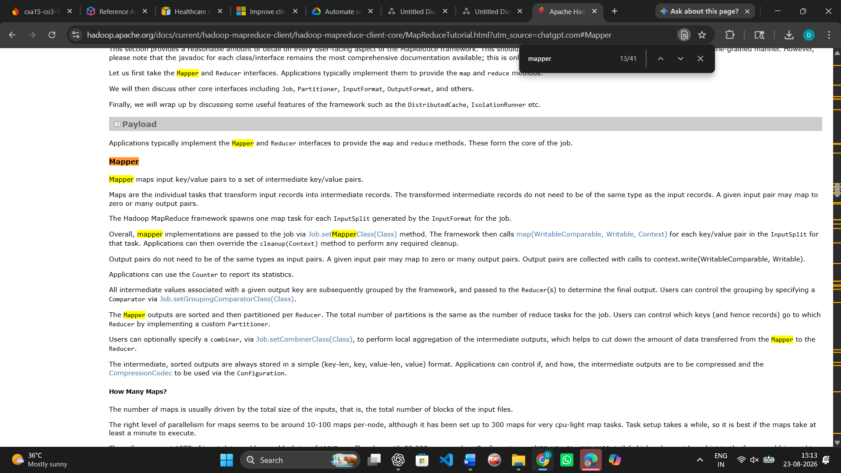
Evidence 1: Apache Hadoop MapReduce – Mapper Documentation
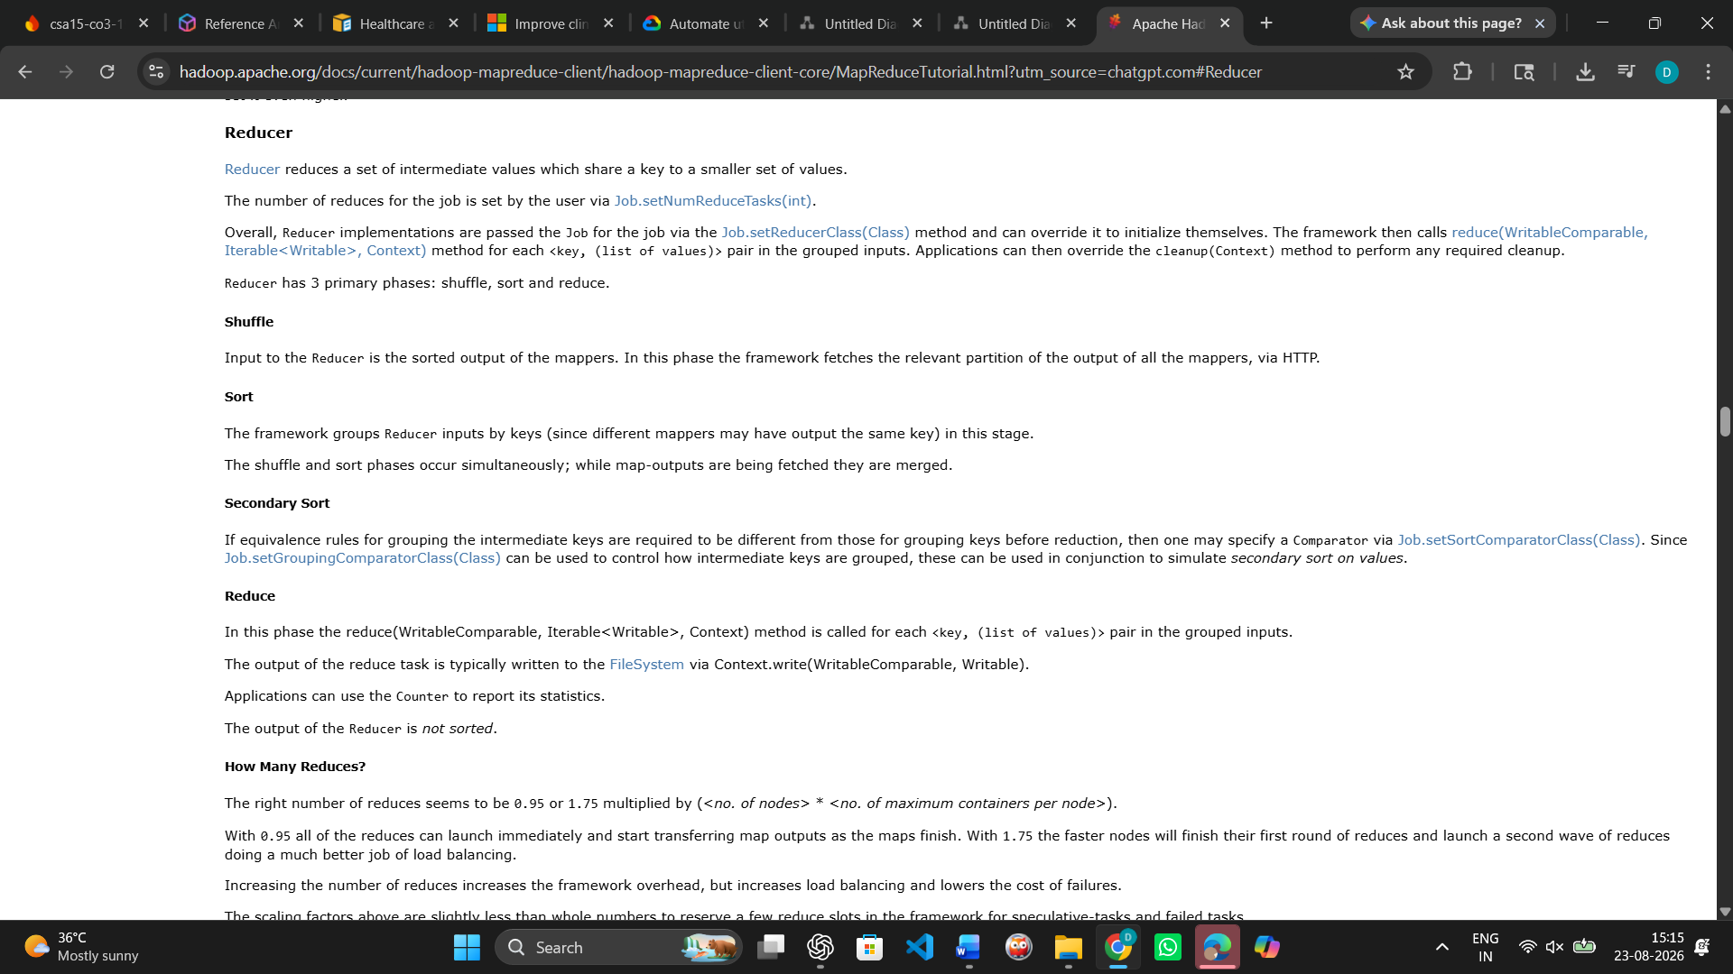
Evidence 2: Apache Hadoop MapReduce – Reducer Documentation
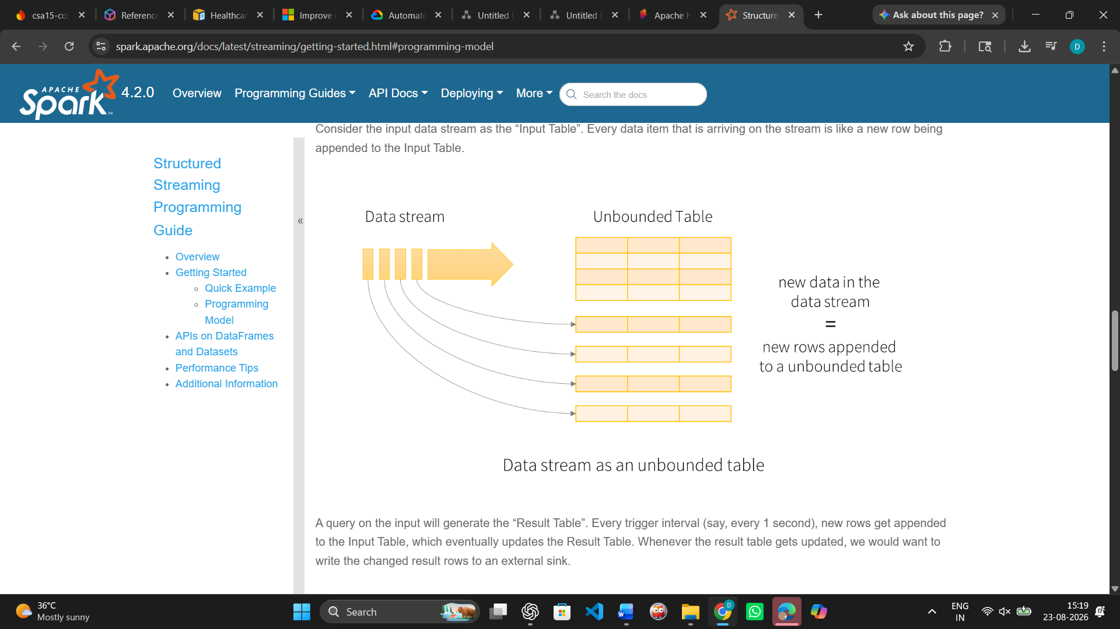
Evidence 3: Apache Spark Structured Streaming – Programming Model

Guided Tool Module 3: Threat Modeling with OWASP Threat Dragon / Microsoft Tool
Purpose: Identify privacy and security risks in the big-data solution before proposing controls.
Tool Choice
Use OWASP Threat Dragon if you need a web/desktop cross-platform threat modeling tool. Use Microsoft Threat Modeling Tool when a Windows system is available. The required evidence is the threat model diagram and threat-control table.
No. | Perform |  | Observe / Decide |  | Record in Workbook
1 | Open OWASP Threat Dragon or Microsoft Threat Modeling Tool. |  | A threat model is a security diagram that shows components, data flows, trust boundaries and possible threats. |  | Write which tool you used.
2 | Create a new threat model named with your scenario. |  | Use a clear title such as CO4_AT2_Healthcare_Emergency_Analytics. |  | Paste model name.
3 | Add external entities. |  | External entities are users/systems outside your platform: patient, customer, sensor, payment gateway, bus GPS device, public API. |  | List at least two external entities.
4 | Add processes and data stores. |  | Processes transform data; data stores hold data. Example: ingestion API, stream processor, data lake, warehouse, dashboard. |  | List processes and stores.
5 | Draw data flows and trust boundaries. |  | Trust boundaries mark where security assumptions change: public internet to cloud, app to API, processing layer to storage. |  | Paste screenshot of DFD.
6 | Identify threats using STRIDE thinking. |  | Spoofing, Tampering, Repudiation, Information Disclosure, Denial of Service and Elevation of Privilege help structure risks. |  | Complete the threat table.
7 | Write mitigations. |  | Controls may include authentication, authorization, encryption, masking, audit logs, rate limits, backup and monitoring. |  | Map every threat to one control.
Component / Data Flow |  | Threat |  | Impact |  | Mitigation
Healthcare User |  | Unauthorized User Impersonation (Spoofing) |  | Attacker may impersonate a healthcare user and submit false emergency requests. |  | Use strong authentication, MFA, and secure login.
Healthcare User |  | Denial of Emergency Request (Repudiation) |  | User may deny submitting an emergency request, making actions difficult to verify. |  | Maintain audit logs, timestamps, and user activity records.
Emergency Data Collection |  | Fake Emergency Data Submission (Spoofing) |  | False health or emergency data may enter the system and cause incorrect processing. |  | Authenticate users and validate all submitted emergency data.
Emergency Data Collection |  | Modification of Emergency Data (Tampering) |  | Emergency information may be altered, resulting in inaccurate healthcare decisions. |  | Use integrity checks, encryption, and access controls.
Emergency Data Collection |  | Unauthorized Access to Emergency Data (Information Disclosure) |  | Sensitive healthcare information may be exposed to unauthorized users. |  | Use encryption and role-based access control.
Data Processing & Analytics |  | Manipulation of Analytics Results (Tampering) |  | Modified analytics results may lead to incorrect emergency decisions or alerts. |  | Modified analytics results may lead to incorrect emergency decisions or alerts.
Data Processing & Analytics |  | Analytics Service Overload (Denial of Service) |  | Excessive requests may make the analytics service unavailable during emergencies. |  | Use rate limiting, load balancing, monitoring, and autoscaling.
Healthcare Data Storage |  | Unauthorized Access to Stored Healthcare Data (Information Disclosure) |  | Confidential patient and emergency information may be exposed. |  | Encrypt stored data and enforce strict role-based access control.
Healthcare Data Storage |  | Modification of Stored Healthcare Data (Tampering) |  | Stored healthcare records may be changed or corrupted. |  | Use access controls, integrity checks, backups, and audit logs.
Alert & Notification Service |  | Emergency Alert Service Disruption (Denial of Service) |  | Emergency alerts may be delayed or unavailable to the response team. |  | Use monitoring, rate limiting, redundancy, and reliable notification services.
Alert & Notification Service |  | Modification of Emergency Alerts (Tampering) |  | Altered alerts may send incorrect emergency information to the response team. |  | Use message integrity checks, authentication, encryption, and access control.
Emergency Response Team |  | Unauthorized Emergency Response Access (Spoofing) |  | An attacker may impersonate an authorized responder and access emergency information. |  | Use strong authentication, MFA, and role-based access control.

Threat Model Diagram Evidence
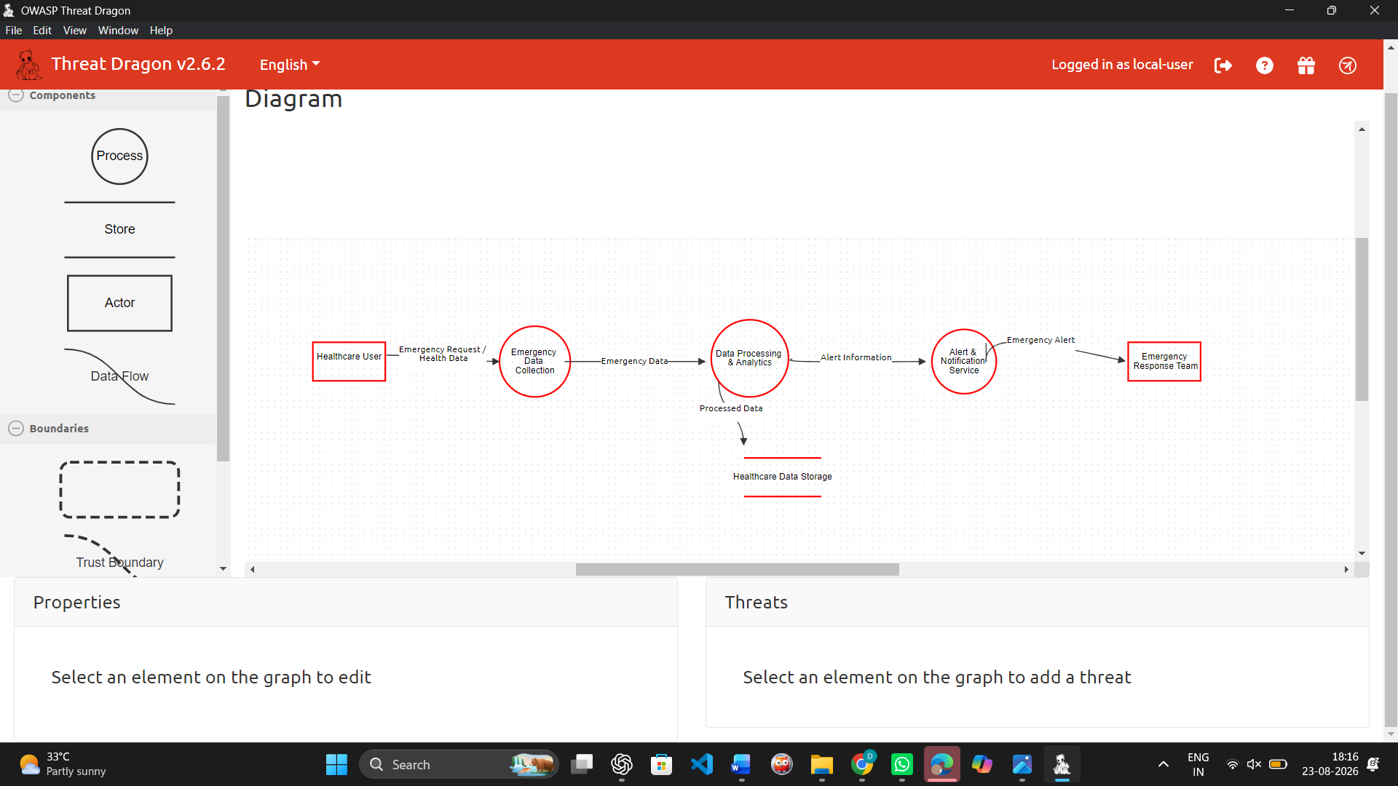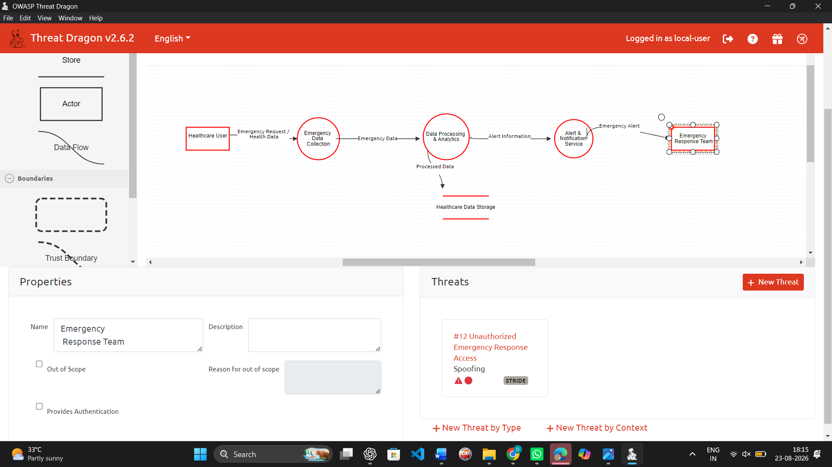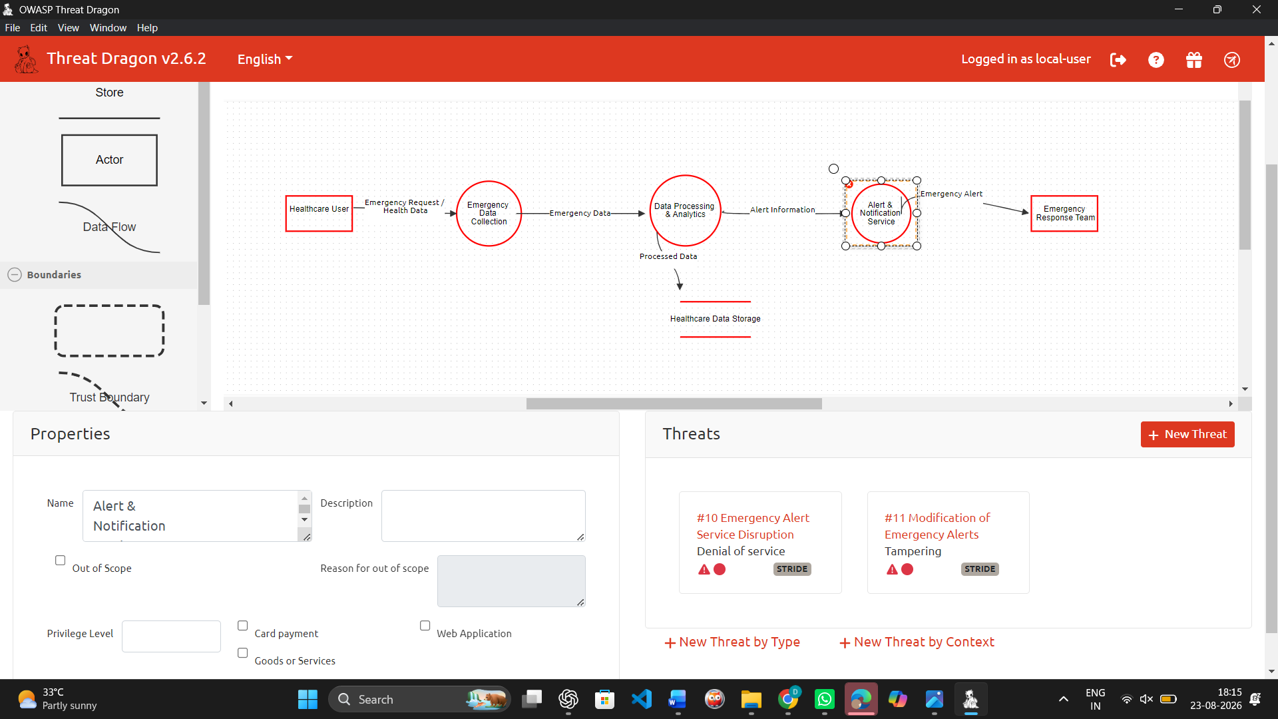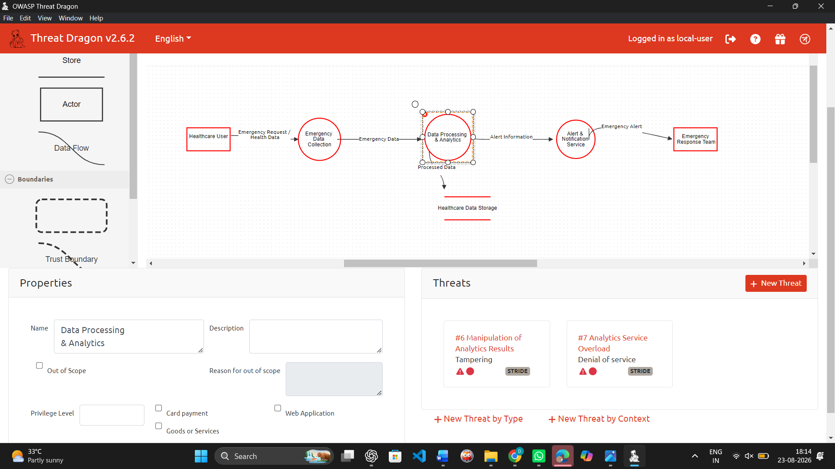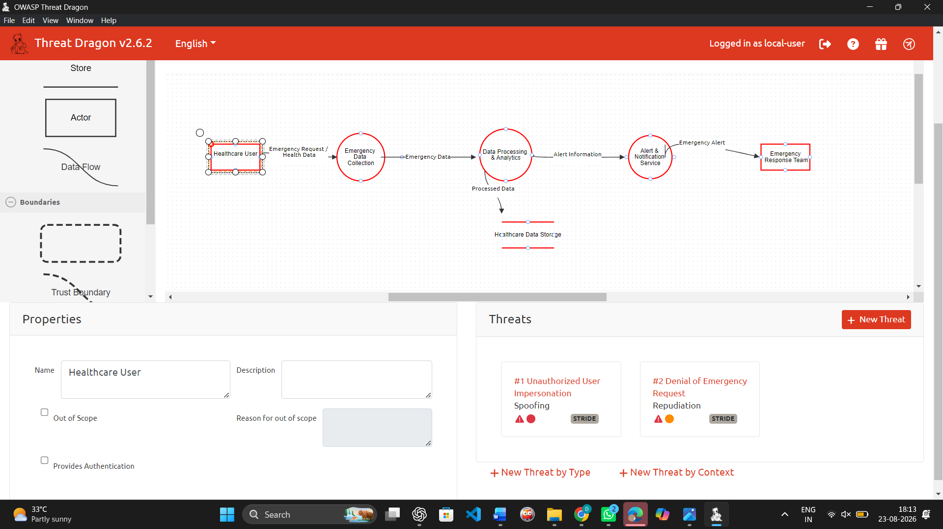

Guided Tool Module 4: Dashboard or Analytics Output Mockup
Purpose: Show how raw big data becomes useful decisions through a dashboard, alert, forecast, recommendation or report.
Beginner-Friendly Choice
Use any one: Power BI, Looker Studio, Tableau Public or Canva. If login/install is difficult, Canva dashboard mockup is acceptable. If data connection is possible, Power BI/Looker Studio/Tableau Public is stronger.
No. | Perform |  | Observe / Decide |  |  | Record in Workbook
1 | Prepare a small sample dataset in Excel or Google Sheets with 10-20 rows. |  | Columns should match your scenario. Example: timestamp, user/location, event type, value, status, risk level. |  |  | Paste column names.
2 | Choose the dashboard tool. |  | Power BI/Tableau/Looker are analytics tools; Canva is acceptable for visual mockup when live data connection is blocked. |  |  | Write chosen tool and reason.
3 | Import or recreate the sample data. |  | In Power BI/Looker/Tableau, connect data. In Canva, manually create charts from sample values. |  |  | Paste screenshot of data/chart setup.
4 | Create at least three visual elements. |  | Use KPI card, bar chart, line chart, table, map, alert count or pie/donut chart as appropriate. |  |  | List the visuals.
5 | Add decision labels. |  | A dashboard is useful only if it supports a decision: allocate beds, detect fraud, reroute buses, restock products, warn farmers. |  |  | Write decision supported by each visual.
6 | Export/share screenshot. |  | Paste the final dashboard screenshot or public/report link if available. |  |  | Paste evidence.
Dataset Column |  | Meaning |  |  | Example Value
Emergency_ID |  | Unique ID of each emergency |  |  | E001
Date |  | Date of emergency |  |  | 01 August 2026
Emergency_Type |  | Type of emergency reported |  |  | Accident
Location |  | Location of emergency |  |  | Chennai
Response_Time_min |  | Time taken to respond in minutes |  |  | 8
Severity |  | Severity level of emergency |  |  | High
Status |  | Current emergency status |  |  | Resolved
Visual Element |  | Metric Shown |  | Decision Supported
KPI Card |  | Total Emergencies |  | Shows the overall number of emergency cases
Bar Chart |  | Emergencies by Emergency Type |  | Identifies the most frequent type of emergency
Donut Chart |  | Emergencies by Severity |  | Identifies high and critical severity cases
Table |  | Emergency Details |  | Helps monitor individual emergency records
Location Slicer |  | Emergencies by Location |  | Helps filter and analyze emergencies by location
Status Slicer |  | Emergency Status |  | Helps filter pending and resolved emergencies
Column Chart |  | Emergencies by Location |  | Identifies locations with more emergency cases
KPI Card |  | Average Response Time |  | Helps evaluate emergency response
Pie Chart |  | Emergencies by Status |  | Shows the proportion of pending and resolved cases

Dashboard / Analytics Output Evidence
Type response / paste screenshot / paste diagram here.
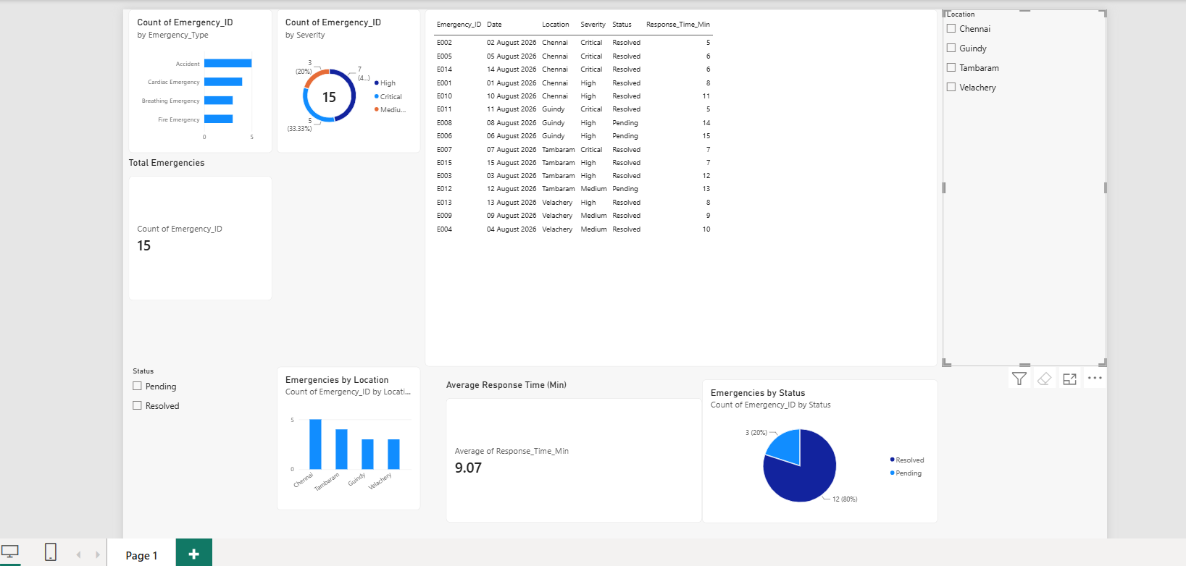

Final CO4 AT2 Solution Sections
Final Assembly
After completing the guided tool modules, combine the evidence into the final solution. The final answer must show technical reasoning, not only screenshots.

1. Problem Understanding
What to include: Identify stakeholders, decisions required, data produced, expected analytics output and urgency.

Student Response
The Healthcare Emergency Analytics system is designed to analyze emergency-related data and support faster healthcare decisions. The main stakeholders are patients, healthcare staff, emergency response teams, and administrators. The system collects data such as emergency type, location, severity, response time, date, and status. This data is processed to identify critical emergencies, high-demand locations, response delays, and emergency trends. The expected analytics output includes total emergency cases, emergency type distribution, severity analysis, location-wise emergency count, average response time, and emergency status. Since healthcare emergencies require immediate action, real-time monitoring and timely analysis are important for improving emergency response and decision-making.

2. 5Vs Mapping
What to include: Map Volume, Velocity, Variety, Veracity and Value using scenario evidence.

Student Response
The Healthcare Emergency Analytics system can be analyzed using the 5Vs of Big Data:
- Volume: A large amount of emergency data is generated from patients, healthcare systems, emergency requests, and historical records.
- Velocity: Emergency information such as new cases, severity updates, response status, and alerts may arrive continuously and must be processed quickly.
- Variety: The system handles different types of data such as emergency type, location, severity, response time, date, status, and healthcare records.
- Veracity: Emergency data must be accurate, validated, and reliable because incorrect or duplicate information can affect healthcare decisions.
- Value: Analyzing emergency data helps identify critical cases, monitor response time, locate high-demand areas, understand emergency trends, and support faster healthcare decisions.

3. Big Data Architecture
What to include: Paste final draw.io architecture showing sources, ingestion, storage, processing, analytics/security and users.

Student Response
The proposed Healthcare Emergency Analytics architecture follows the flow:
Healthcare Users / Emergency Data Sources → Data Collection / Ingestion → Cloud Storage → Data Processing and Analytics → Alert and Notification Service → Emergency Response Team / Dashboard
Emergency information such as emergency type, location, severity, response time, and status is collected through the data ingestion layer. The collected data is securely stored in cloud storage. Hadoop MapReduce can process historical batch data, while Spark Structured Streaming can process continuously arriving emergency information. The processed information is used for analytics, dashboards, and emergency alerts. Authentication, role-based access control, encryption, and monitoring are used to protect healthcare data.
Architecture Evidence: Paste the final draw.io architecture diagram created in Module 1 here.

4. Data Flow Pipeline
What to include: Explain how raw data moves, gets cleaned, stored, processed and converted into dashboard/alert/decision.

Student Response
Emergency data is generated from healthcare users and emergency data sources. The data is collected through the ingestion layer and validated before being stored in cloud storage. Historical data is processed in batches using Hadoop MapReduce, while continuously arriving emergency updates can be processed using Spark Structured Streaming. The processing layer analyzes emergency type, severity, location, response time, and status. The processed results are then displayed through the analytics dashboard and used to generate alerts. Healthcare administrators and emergency response teams can use these outputs to identify critical cases and make faster decisions.

5. Tool and Technology Justification
What to include: Use cloud architecture references and Hadoop/Spark documentation to justify chosen tools.

Student Response
Cloud architecture is suitable for Healthcare Emergency Analytics because it provides scalable storage, processing, analytics, and secure access to emergency data. AWS, Microsoft Azure, and Google Cloud architecture references were studied to understand common cloud patterns such as data ingestion, cloud storage, processing, analytics, visualization, and security.
A hybrid processing approach is suitable for the solution. Hadoop MapReduce can process large volumes of stored historical data in batches, while Spark Structured Streaming can process continuously arriving emergency events and updates. Power BI is used to visualize the processed data through KPI cards, charts, tables, and filters, making the emergency information easier to analyze and use for decision-making.

6. Security and Privacy Strategy
What to include: Use threat model output to explain threats and controls.

Student Response
Healthcare emergency data may contain sensitive information and therefore requires strong security and privacy controls. The threat model identified risks such as spoofing, tampering, information disclosure, denial of service, and unauthorized access.
Strong authentication and MFA can reduce user impersonation. Role-based access control ensures that only authorized healthcare users can access sensitive information. Encryption protects data during storage and transmission. Input validation and integrity checks help prevent modification or submission of false emergency data. Audit logs and timestamps provide accountability. Rate limiting, monitoring, load balancing, backups, and redundancy can improve system availability and protect emergency services from disruption.

7. Challenges and Solutions
What to include: Write at least four big-data implementation challenges and one practical solution for each.

Student Response
Challenge | Practical Solution
Large volume of healthcare emergency data | Use scalable cloud storage and distributed processing.
Continuous arrival of emergency updates | Use Spark Structured Streaming for real-time processing.
Inaccurate or incomplete emergency data | Apply data validation, cleaning, and integrity checks before processing.
Security and privacy of healthcare information | Use encryption, strong authentication, MFA, and role-based access control.
High demand during emergency situations | Use load balancing, autoscaling, monitoring, and reliable cloud services.

8. Business Outcome
What to include: State measurable outcome: faster decision, reduced fraud, lower waiting time, improved prediction, lower downtime or better user experience.

Student Response
The Healthcare Emergency Analytics solution can improve emergency response by converting raw emergency data into useful and timely information. The Power BI dashboard provides information such as total emergencies, emergency type distribution, severity levels, location-wise cases, average response time, and emergency status. These analytics can help healthcare administrators and emergency response teams identify critical cases, detect locations with higher emergency demand, monitor response performance, and make faster decisions. The expected outcomes are reduced response delays, improved resource allocation, better monitoring, and improved emergency service efficiency.

Rubric
Criteria | Marks | Evaluation Focus | Evidence
Problem and 5Vs analysis | 6 | Scenario-specific analysis and correct big-data reasoning | Workbook tables
Architecture and data flow | 6 | Correct pipeline, cloud components and flow clarity | draw.io diagram
Processing framework decision | 5 | Batch/streaming/hybrid justification using Hadoop/Spark concepts | Decision table
Security and privacy | 5 | Threat model, risks and controls | Threat model table/screenshot
Dashboard/output design | 4 | Useful decision-oriented analytics output | Dashboard/mockup
Clarity and submission quality | 4 | Organized, original, complete evidence | GitHub/GCR

Submission Checklist
- Student details and selected scenario are filled.
- Cloud architecture references are recorded.
- Hadoop/Spark processing decision is completed.
- Threat model diagram/table is included.
- Dashboard/mockup screenshot or link is included.
- Final solution sections are completed.
- DOCX/PDF and supporting files are uploaded to GitHub.
- GitHub repository link is submitted through Google Classroom.

Official Reference Links
AWS Architecture Center: https://aws.amazon.com/architecture/
Azure Architecture Center: https://learn.microsoft.com/en-us/azure/architecture/
Google Cloud Architecture Center: https://docs.cloud.google.com/architecture
Apache Hadoop MapReduce Tutorial: https://hadoop.apache.org/docs/stable/hadoop-mapreduce-client/hadoop-mapreduce-client-core/MapReduceTutorial.html
Apache Spark Structured Streaming: https://spark.apache.org/docs/latest/streaming/index.html
Microsoft Threat Modeling Tool releases: https://learn.microsoft.com/en-us/azure/security/develop/threat-modeling-tool-releases
OWASP Threat Dragon: https://owasp.org/www-project-threat-dragon/
Power BI documentation: https://learn.microsoft.com/en-us/power-bi/
Looker Studio create report: https://docs.cloud.google.com/data-studio/create-a-report
Tableau Public: https://www.tableau.com/community/public
Canva Charts: https://www.canva.com/help/charts/

